**University of Southern California**

Viterbi School of Engineering

CSCI 599: Content Detection and Analysis for Big Data

**Instructor**:Dr. Chris Mattmann

Assignment 3: Evaluating the Content Analysis Text Retrieval Conference (TREC)

Polar Dynamic Domain Dataset

**TEAM 22**

**GitHub repository**: *https://github.com/harshfatepuria/Evaluation-of-Content-Analysis-on-TREC-Polat-DD-Dataset*

**Github.io website**: [*http://harshfatepuria.github.io*](http://harshfatepuria.github.io)

*(All the visualizations with interactive capabilities available on this website)*

Date: 05/03/2016

Report submitted by:

Harsh Fatepuria, *fatepuri@usc.edu*

Warut Roadrungwasinkul, *roadrung@usc.edu*

Rahul Agrawal, *rahulagr@usc.edu*

(Graduate Students, Department of Computer Science)

1. **Examining the Polar Common Crawl Dataset**

To examine properties of Polar Common Crawl Dataset, we develop a parser, CCADetailParser, to extract various properties of CBOR documents in the dataset as metadata, including

1. Requested URL and keywords extracted from the URL
2. Response HTTP status
3. Detected media type
4. Parser chain (the "X-Parsed-By" metadata field)
5. File size
6. Size of text retrieved
7. Size of metadata retrieved
8. Named entities recognized from the text using CoreNLP and 3 classes mode
9. **Classification path from Request to Content**
10. Using CCADetailParserRunner, we run this parser with a portion of the dataset (‘*572-team6-acadis-plain*’ and ‘*572-team41-ade*’ directories). We use the extracted information to study the relationship between URL keyword and extracted named entities.  We develop visualizations of this relationship using D3. For readability, we will show 10 most frequent named entities of each class from 30 most frequent normalized keywords (stemming and stopwords removed using python *stemming* and *stop_words* library) and also from 30 normalized keywords that can extract highest amount of named entities.
11. Named entities present on the arrived at page: Person, Location and Organization

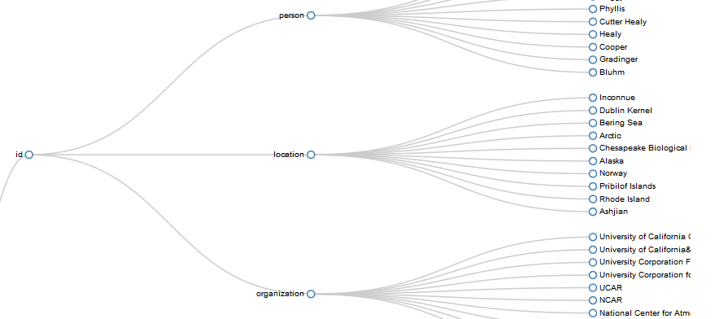

Fig 1: Showing 10 most frequent named entities of each class from 30 most frequent normalized keywords

1. Yes the crawler found the most relevant web pages. The request URL and the contents of the retrieved pages, and the named entities extracted had stark resemblance.
   1. To run the Parser: **java** ccaparser.CCADetailParserRunner *baseFolder resultFolder markerFile*
   2. To create data for visualization: **python** urlKeywordToNer.py *ccaDataBaseFolder*

Snippet 1: Running the Parser for path from Request to Content

1. From the extracted data, we develop a script to summarize file size statistics of each file type. D3 visualization of this information is also provided.
2. To create data for visualization: **python** sizeSummary.py *ccaDataBaseFolder*

Snippet 2: Generating visualization

1. **File size diversity of Common Crawl (CCA) dataset by MIME type**
2. The file size ratio of the Solr Index to the original file sizes were computed and averaged over 100 files from each MIME type. D3 visualization depicting the same is shown below:

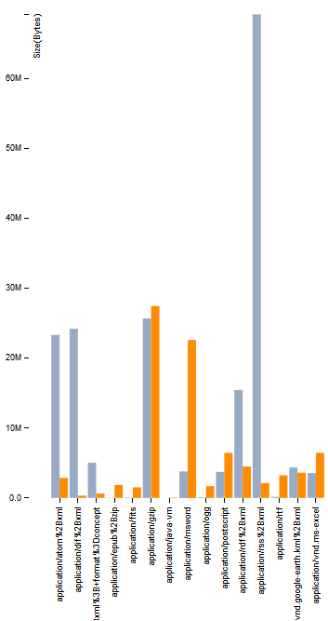

Fig 2: File Compression Ratio. (Orange line represents the actual file size, and the Blue line represents the size of its Solr Index)

1. **Parser Call Chain**
2. The CCADetailParser can be used with actual file by itself but it will not extract request information. We run the parser with entire Polar fulldump dataset using FileDetailParserRunner. D3 Interactive Sunburst can be used to visualize the parser hierarchy against other information. We develop the visualizations of parser hierarchy against number of document per file type, ratio of metadata retrieved to file size per file type, and ratio of text retrieved to file size per file type.

To run the Parser: **java** ccaparser.FileDetailParserRunner *baseFolder resultFolder markerFile*

To create data for visualization: **python** parserChain.py *ccaDataBaseFolder fullDumpDataFolder*

Snippet 4: Running the Parser for Parser Chain Call

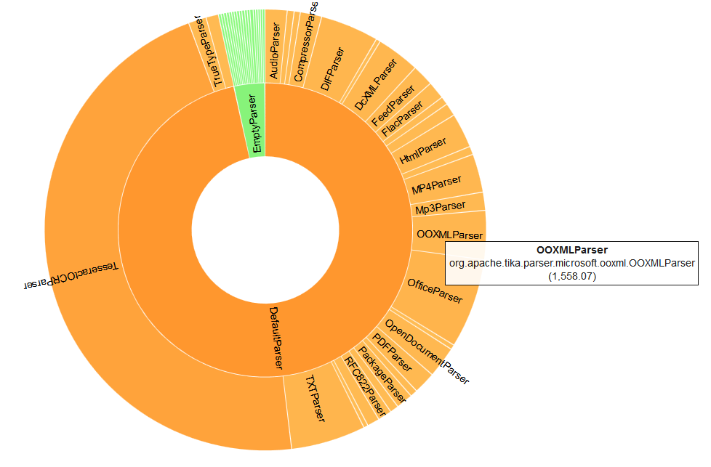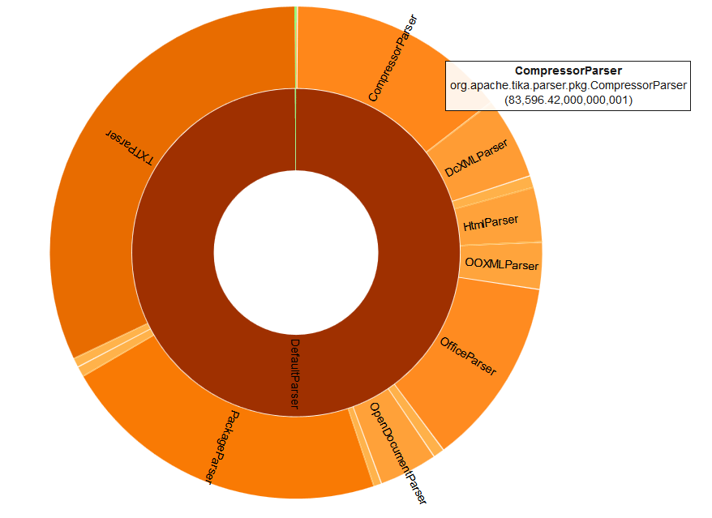

Fig 3: Amount of Text (left) and Metadata (right) retrieved per MIME type v/s parser chain hierarchy

1. Plot of the amount of Text retrieved per MIME type v/s Parser and the amount of Metadata retrieved per MIME type v/s parser chain hierarchy is shown above.
2. **Language Identification and diversity**
3. We will compare Tika language detection feature with Optimaize language detector library. We run this with entire Polar fulldump dataset and produce D3 visualization of the result. The visualization show that around 300k files are detected to be *lt-Lithuanian* by Tika but Optimaize only detect 42 files. Also, around 300k files are detected to be *unknown* by Optimaize but Tika only detect 8 files. We think this might be an outlier related to detecting empty file. We try to run the language detection again by filtering out the files that have too few text retrieved (<1000 characters). The result shows that number of documents detected to be *lt-Lithuanian* by Tika is significantly lower to 20k and number of documents detected to be *unknown* by Optimaize is lower to 7k. *That means amount of text will play an important role for language detection accuracy.*

To run the language detector: **java** language.LanguageDetectRunner *baseFolder resultFolder minSize*

To create data (csv) for visualization: **python** languageCompare.py *languageDetectedFolder*

Snippet 5: Running the LanguageDetectRunner

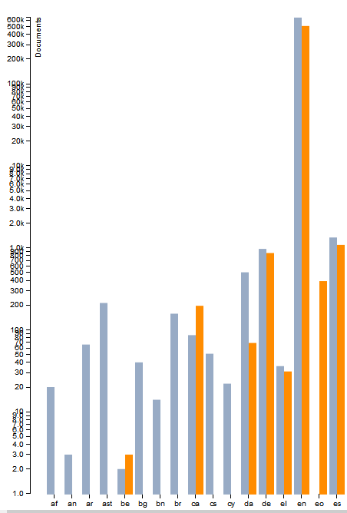

Fig 4: Language Detection. Orange line-Tika Language Detection and Blue line- Optimaize

Language Detected (y-axis) v/s Number of Files (x-axis)

1. To study documents with mixed language, we will try to split extracted text into chunks (maximum at 10 chunks for a file) then use Tika language identifier to detect language of each chunk. We then compare detected language from full text to the majority of detected language of each chunks. If they are not the same, it will possibly indicate the file contains multiple language. We then make a visualization of the rate which language detected from parts and whole file are not the same. Though the rate is not much, it will be an evidence that some files in the dataset contains multiple language.

To run the mixed language detector: **java** language.MixedLanguageDetectRunner *baseFolder resultFolder*

Snippet 6: Running the MixedLanguageDetectRunner

1. **Maximal occurring topics in the dataset**
2. After running various parsers built during the course of Assignment 2 and this project, including measurement parser, SWEET ontology parser, GeoTopic parser and other metadata extractors, a set of maximally occurring words were obtained from each of the parsers. The results are combined and presented in the form of Word Cloud below:

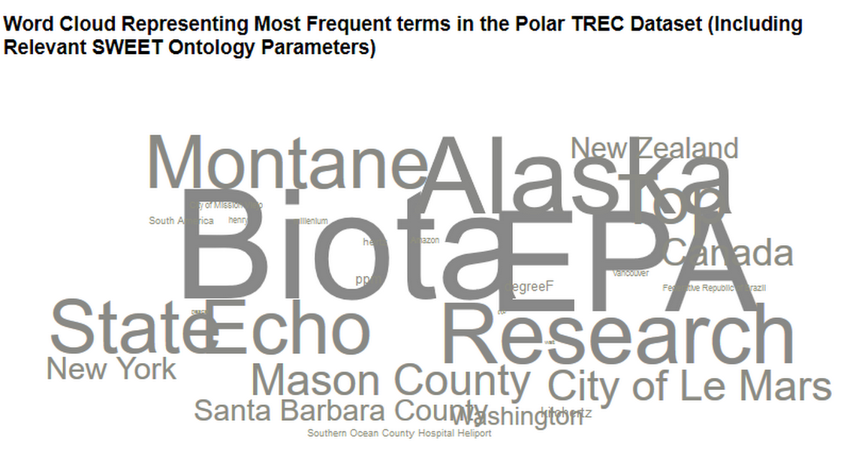 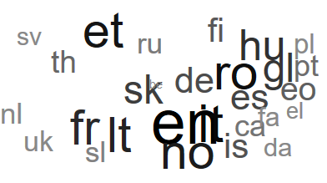

Fig 5: Word Cloud representing the maximal occurring topics including SWEET concepts(left), language diversity (right) in the dataset

1. Observation: Highest number of documents are in English. However, there is a great diversity of languages in the dataset. Also, since this is the Polar Dynamic domain dataset, we can clearly see that there is a large mention of places with huge ice shelves, namely, Alaska, Canada etc.
2. **Named Entity Recognition Agreement:**
3. NLTK, CoreNLP, openNLP and Grobid Quantities are NER recognizers used to extract named entities for the data. After setting them up, we employ them in the CompositeNERAgreementParser. The NER agreement list can be obtained by accumulating most common named entities extracted from all 3 recognizers until the size of the list exceeds defined threshold. We can configure the parser whether to apply TTR analysis to the extracted text before doing named entity recognition. We run the parser with first 1500 files of each MIME type from the Polar fulldump dataset. D3 visualization is made to display 200 most common named entities extracted by the recognizers.

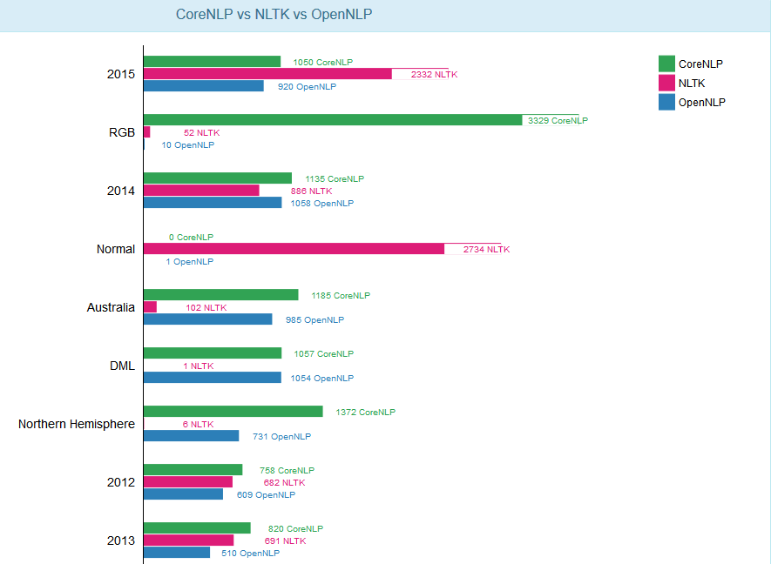

Fig 6: Maximal join agreement between the three NER toolkits.

To run the parser: **java** ner.NERAgreementParserRunner *baseFolder resultFolder markerFile typeJsonFolder*

To create data for visualization: **python** nerAgreement.py *extrectedNERFolder*

Snippet 7: Running the NER Agreement parser

Since entities extracted via Grobid Quantities Parser is not much in agreement with the above three toolkits, a separate visualization was developed for extracted measurements.

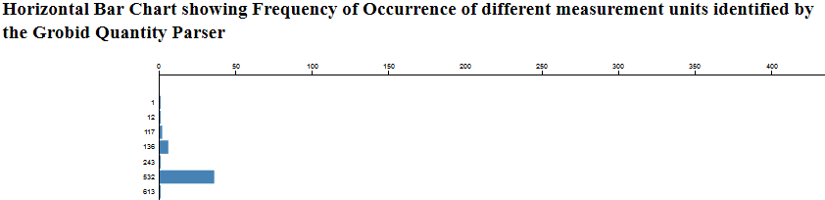

Fig 7: Grobid Quantities- extracted measurements and their counts (please see github.io website for more clarity)

1. [Extra Credit] Grobid Quantities:

A Tika NER implementation that invokes Grobid Quantities via its REST service was developed. A pull request to

merge the implementation is submitted.

To run the parser and create data for visualization: **java** ner.GrobidQuantitiesNER

Snippet 8: Running the Grobid Quantity parser implemented by us

1. Our new joint agreement (as described in NERAgreementParserRunner.java file) produces updated NER for the metadata records. We added the new maximal joint agreement NERs to the metadata records in our Solr Index, which can be seen in the attached Solr schema file.
2. **Spectrum of Measurements**
3. A program (measurementParser.py) was developed which takes the various measurement extractor entities- developed as a part of Assignment 2, and the measurements extracted using Grobid Quantities and generates JSON in three formats:
4. Max, Min and Average for all the different measurement units.
5. All measurements clustered based on domain: A dictionary of high level domain and related measurement units was manually and meticulously curated. A sample entry in dictionary looks like:

{

"TEMPERATURE":["kelvin", "celsius", "celcius", "fahrenheit", "degreeC", “degreeF” … ]

}

1. Measurements clustered based on the MIME types: A script was developed to map each file in the dataset to its MIME type. This was generated using a list generated as a part of Assignment 1 which maps each MIME type to the list of file-paths it refers to. Then the measurements extracted for each files were clustered based on the MIME type of that file. A Sample JSON for the D3 visualization is shown below:

{

“name”: Measurement Range Clustered on MIME Type”,

"children": [{

“name”: “application/x-sh”,

"children": [

{"name": "hour", "size": 3},

{"name": "kelvin", "size": 2},

{"name": "month", "size": 1}

…

} … ]

…

}

Snippet 9: Mapping Domain to Units (ii) and JSON file for D3 generation (iii)

1. Various visualizations for the above generated spectrum of measurements were created:

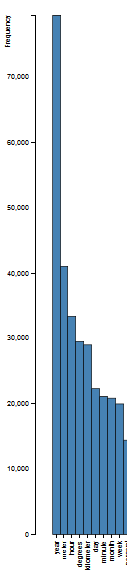

Fig 8: Bar Chart depicting extracted measurement units and their frequency

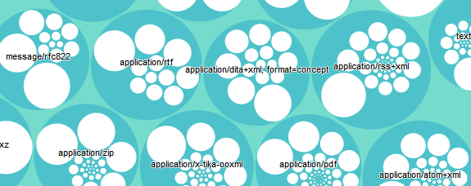

Fig 9: Circle Packing showing Measurement units clustered based on MIME types. Note that the data has been normalized for visualization purposes. See Github.io website for more clarity.

To run the parser and create data for visualization: **python** measurementParser.py

Snippet 10: Running the Measurement parser implemented by us to get data for visualizations

1. Observation: In MIME type application/google-earth, the maximally occurring key word is ‘degree’ referring to longitudinal and latitudinal minutes with an occurrence of over 95%. Overall, in the whole dataset, ‘year’ is the most used unit, double the count of second most used unit, ‘meter’.
2. **Contributions to** [**http://www.polar.usc.edu**](http://www.polar.usc.edu) **and Video Demonstration:**
3. We have previously contributed our visualizations to polar.usc.edu in both, Assignment 1 and Assignment 2. We have also added a pull request for the visualizations developed as a part of this assignment.
4. Video demonstrating a screencast walk-through to the tasks is available at: https://youtu.be/lChEX_gn65g
5. **D3 Visualizations**:

The D3 visualizations can be found in the different directories present in the *result* directory of the submission.

|  |  |
| --- | --- |
| **Visualization File Name** | **Description** |
| UrlKeywordToNer-MostFrequentKeyword.html | Most frequent URL Keywords vs Extracted NER |
| UrlKeywordToNer-MostNerExtracted.html | URL Keywords that produce most NE vs Extracted NER |
| SizeRatioSummary.html | Size Ratio of Solr Index to Original File Size (Grouped By MIME Type) |
| SizeSummary.html | File Size Summary |
| ParserVsCount.html | Parser Hierarchy vs Document Count by Type |
| ParserVsMetadataRetrieved.html | Parser Heirarchy vs Size of Metadata Retrieved Ratio by Type |
| ParserVsTextRetrieved.html | Parser Heirarchy vs Size of Text Retrieved Ratio by Type |
| ParserVsTTRRetrieved.html | Parser Heirarchy vs Size of TTR Text Retrieved Ratio by Type |
| LanguageCompareFilter.html | Number of Documents by Detected Language (filtered out short documents) |
| MixedLanguage.html | Tika Mixed Language Detection |
| WordCloudD3.html | Word Cloud Representing Most Frequent terms in the Polar TREC Dataset (Including Relevant SWEET Ontology Parameters) |
| GrobidQuantityTTR.html | Horizontal Bar Chart showing Frequency of Occurrence of different measurement units identified by the Grobid Quantity Parser |
| NERAgreementFullText.html | CoreNLP vs NLTK vs OpenNLP |
| Measurement_ByDomain.html | Zoomable Circle Packing D3 Showing vaious Measurement Quantities(Grouped By Domain) |
| Measurement_ByMIME.html | Zoomable Circle Packing D3 Showing vaious Measurement Quantities(Grouped By MIME Type) |
| measurementCountBarChart.html | Bar Chart showing Frequency of Occurrence of different measurement units |
| Measurement_Range.html | Dendogram showing Minimum, Maximum, and Mean values of Measurement Units |

1. **Important Observations**:
2. Yes, our MIME detection was good. We used Apache Tika’s inbuilt parsers to parse the dataset, and categorize the data into MIME types. We also ran Mac Operating System’s inbuilt MIME detector using the command: *file --mime-type -b <file_name>*

Not surprisingly, **almost 99% of the files were detected the same**. There were certain files in the application/octet stream which were not detected by Tika, but were identified by Mac OS as text-plain.

Out of around 1.7 M files in the dataset, around 200,000 files were detected to be application/octet stream, which amounts to an accuracy of 88% correct detection.

1. Yes, our parsers are extracting the right text. During the course of the three assignments, we built many parsers like measurement extractor, geo topic parsing extractor, used MEMEX geoparser etc. Also, we developed many wrappers for toolkits like openNLP, Core NER, NLTK and Grobid Quantities. These parsers are extracting the correct text, which is evident from the fact that they are in agreement to each other. More details for this agreement can be seen in the visualizations provides.
2. Tika identifies the correct parser most of the time to parse any input file. This provides us with the required and relevant data from each input file. This is evident from the Parser Hierarchy Visualizations created by us.
3. The Metadata identified by Tika is highly appropriate, as seen from the metadata scores obtained in Assignment 2. We try to enrich the metadata using various techniques taught to us in class. All these new metadata parameters were dumped in Solr with respect to each file we worked with. These new metadata fields include geolocations, SWEET Ontology concepts, related publications (for PDF files), and measurement units present.
4. We compared Tika language detection feature with Optimaize language detector library. The visualization made by us show that around 300k files are detected to be *lt-Lithuanian* by Tika but Optimaize only detect 42 files. Also, around 300k files are detected to be *unknown* by Optimaize but Tika only detect 8 files. We think this might be an outlier related to detecting empty file. We try to run the language detection again by filtering out the files that have too few text retrieved (<1000 characters). The result shows that number of documents detected to be *lt-Lithuanian* by Tika is significantly lower to 20k and number of documents detected to be *unknown* by Optimaize is lower to 7k. *That means amount of text will play an important role for language detection accuracy.*
5. The Named Entities extracted using OpenNLP, CoreNLP, NLTK, and GrobidQuantity are in agreement to each other, and hence make sense. The terms extracted are also in sync with the relevant topics of the TREC Dynamic Polar Dataset.